AName: Pranali Sonawane
Subject: MCSA
Date: 31-12-2025
Lab 19: WDS (Windows Deployment Service)

Server 1: Install WDS
- Add roles and features next next Windows Deployment Services next install.
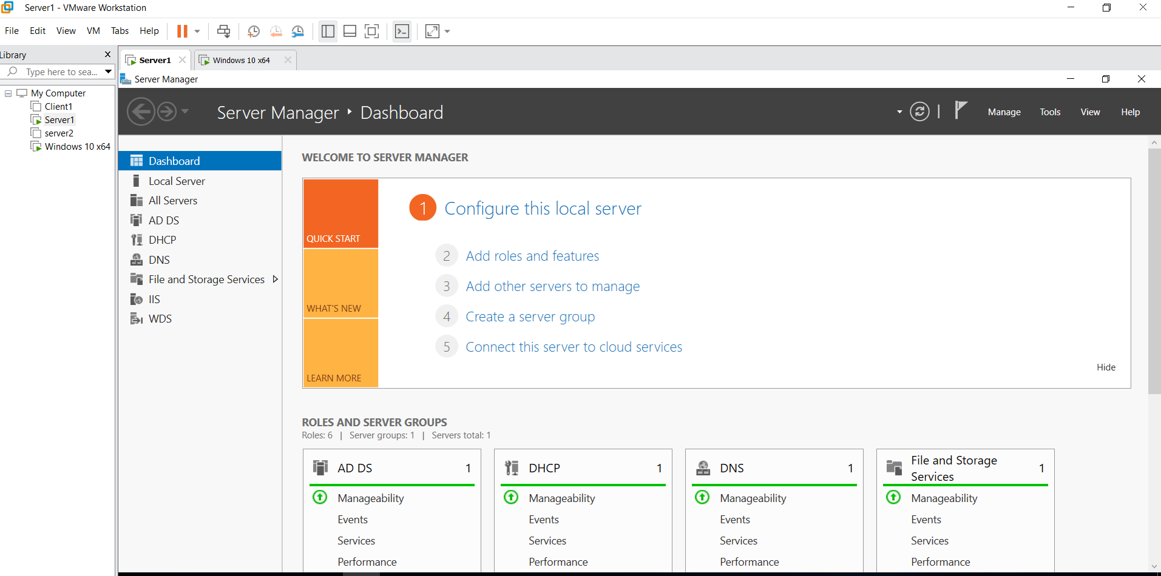
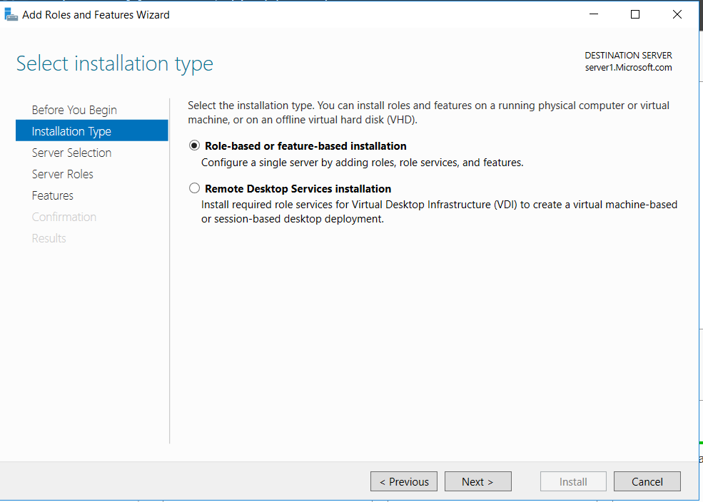
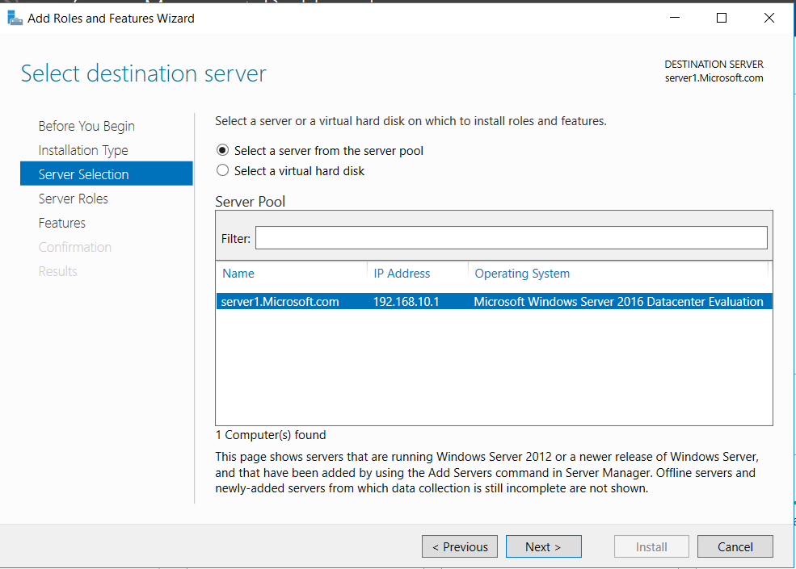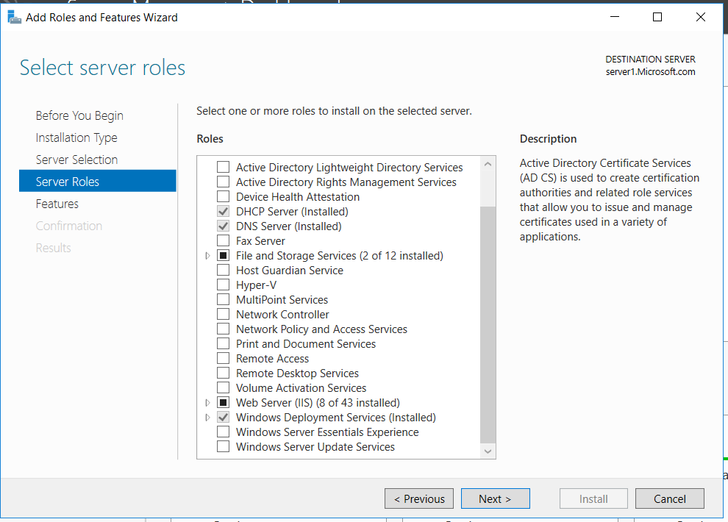
2. Tools WDS Servers Server1.Microsoft.com right click config server Requirement: 1) AD
2) DNS
3) DHCP
4) NTFS Partition
3. Add Hard Disk Formatting hard Disk
4.How to install DHCP
- Dashboard Add Role and Features Next Next Click on DHCP Server(Add Feature) Click on Install Restart
- Tools DHCP IPV4 Create new Scope Name WDS start IP: 192.168.10.41 , end IP : 192.168.10.50 Router DG: 192.168.10.254 next WINS Server next
5. Tools WDS Servers Server1.Microsoft.com Configure Server next Integrated to AD path Browser Select F Drive next Type F:\remoteinstall next Respond to all Client Computers next
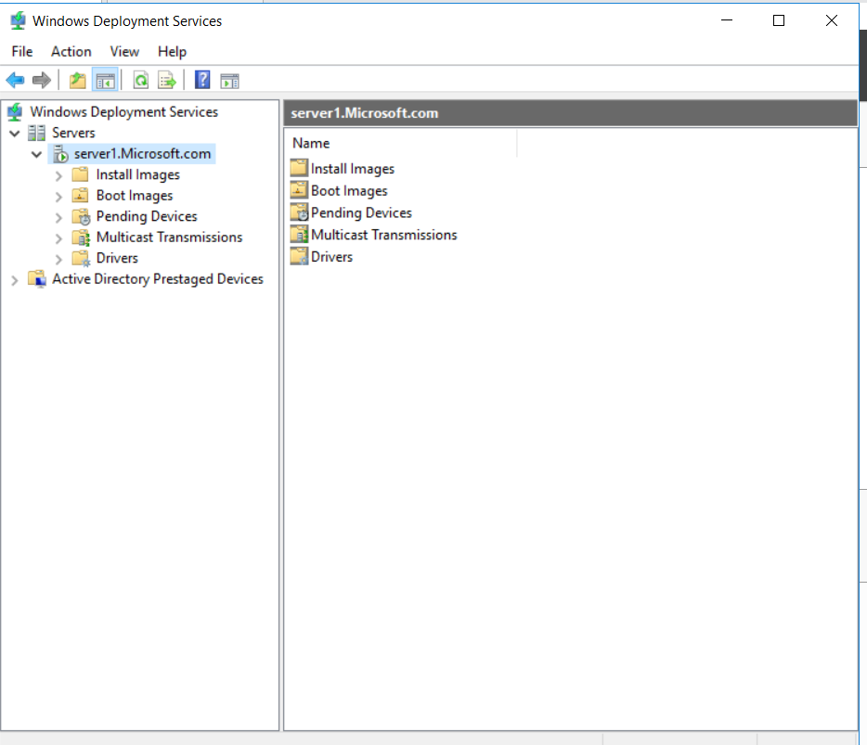
WDS Servers Server1.Microsoft.com right click All Task start
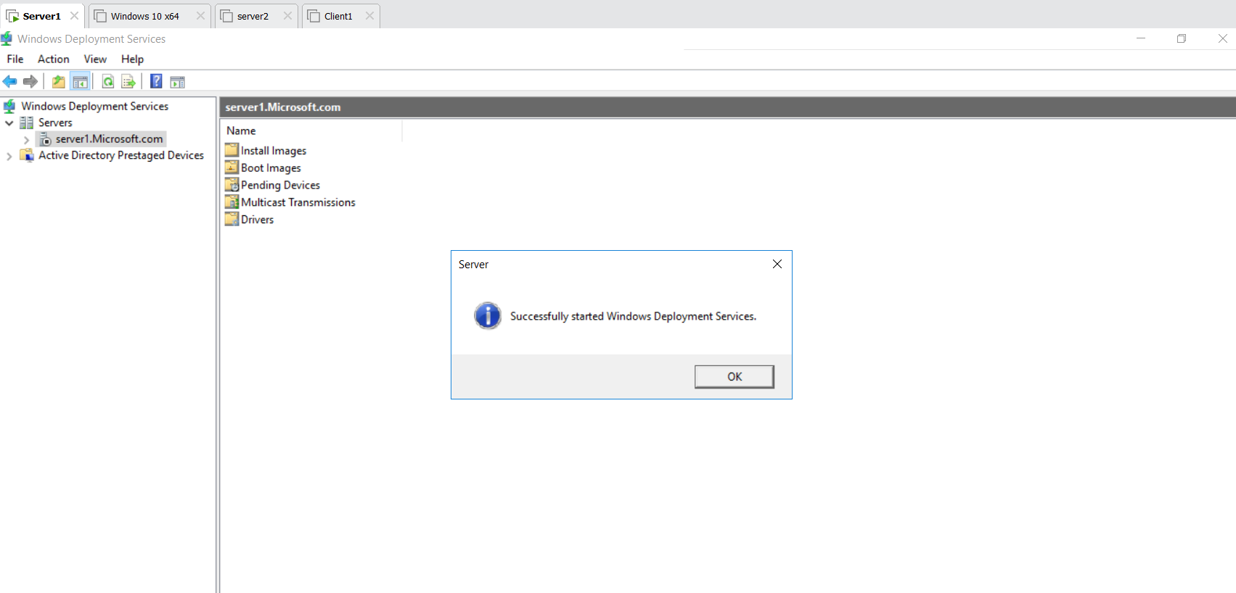
6 .click on Install Images Right Click Add install Image give name ImageGroup1 Select G drive s Source install.wim next Only Select Window 10 Pro N
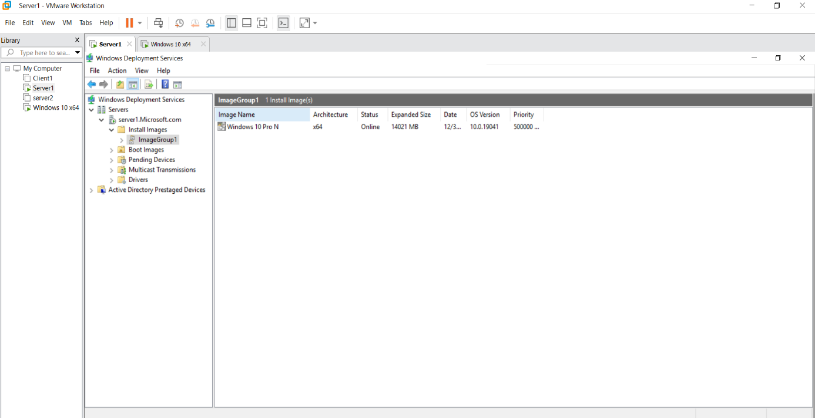
7. click on Boot Images Right Click Add Boot Image next Select G drive s Source boot.wim next
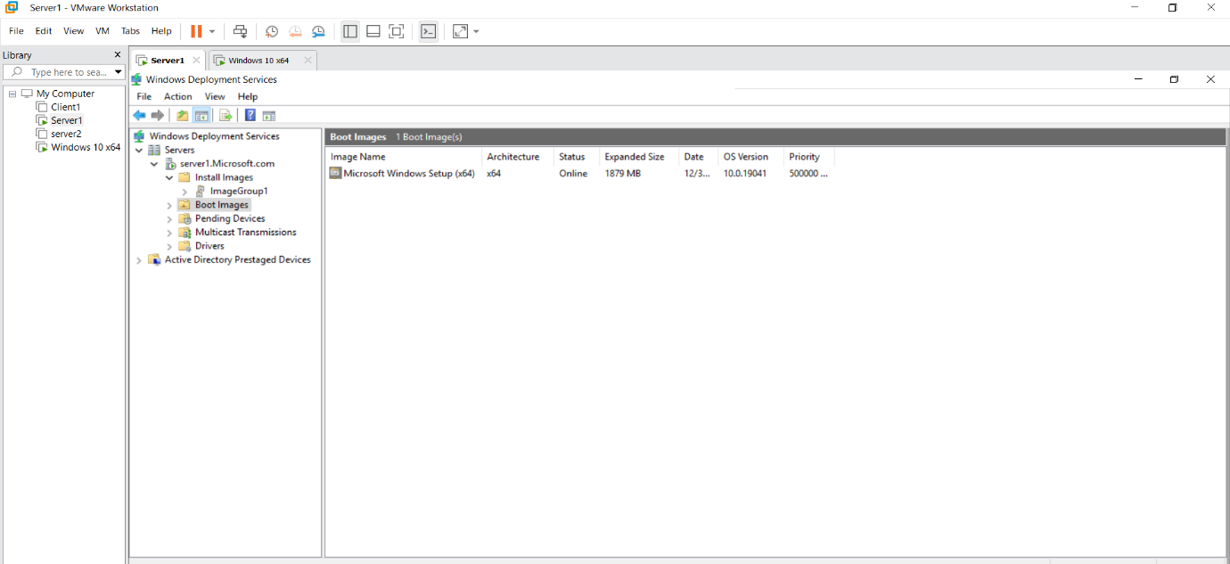
8. Click on File new Virtual Machine 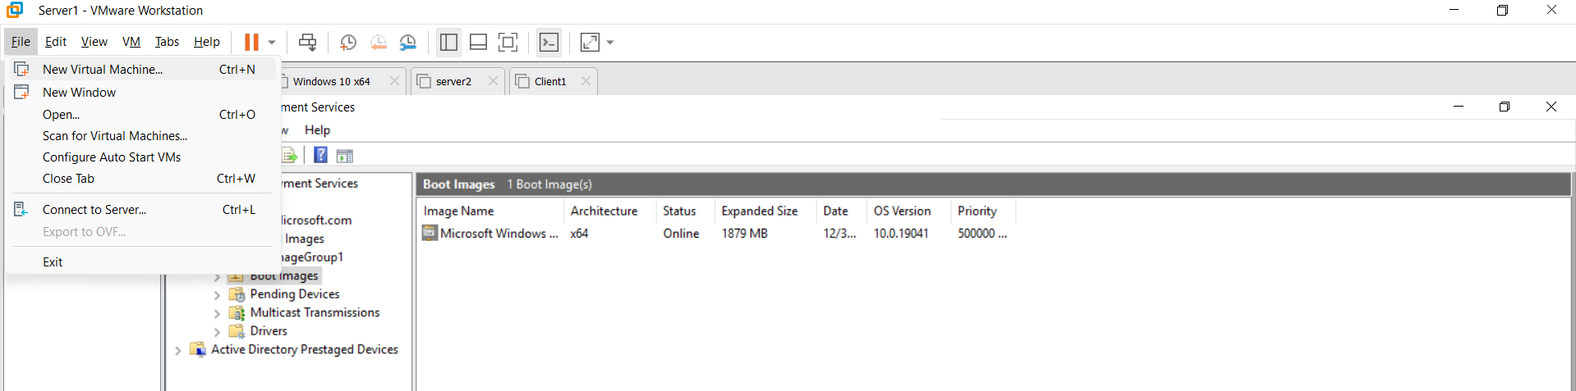
Virtual Machine custom next next windows server 10 x64 This Pc In D drive create Folder WDS Machine 1048 MG next next 30 GB next
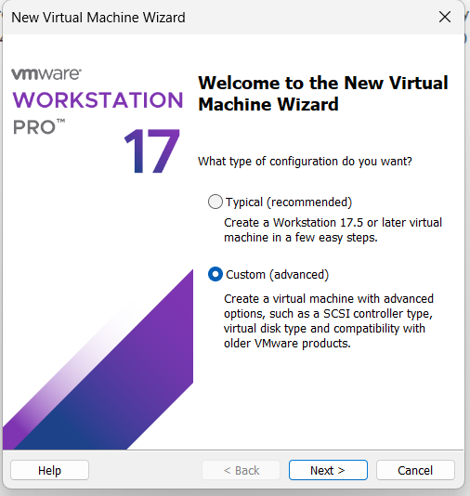
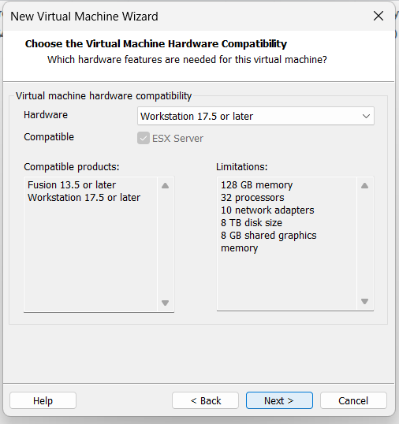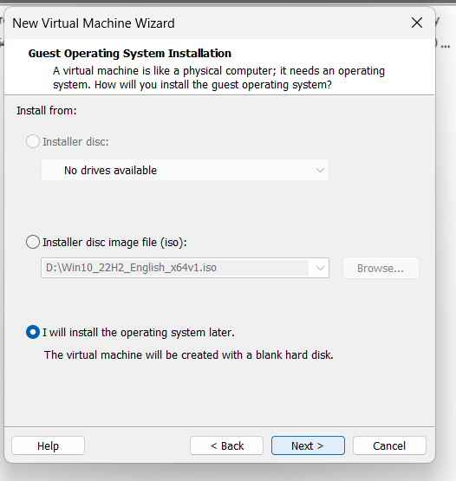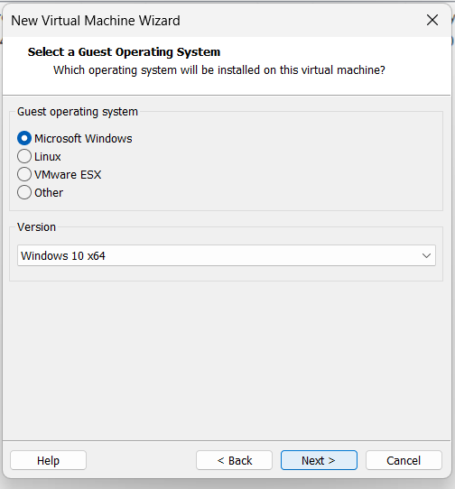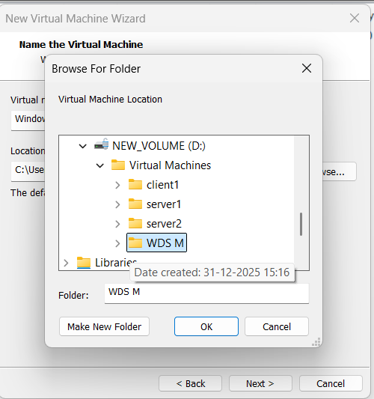
9.Create Windows 10 x64 VM Edit VM Settings Network Adaptor custom Select vmnet2 ok and CD/DVD use iso windows 10 iso
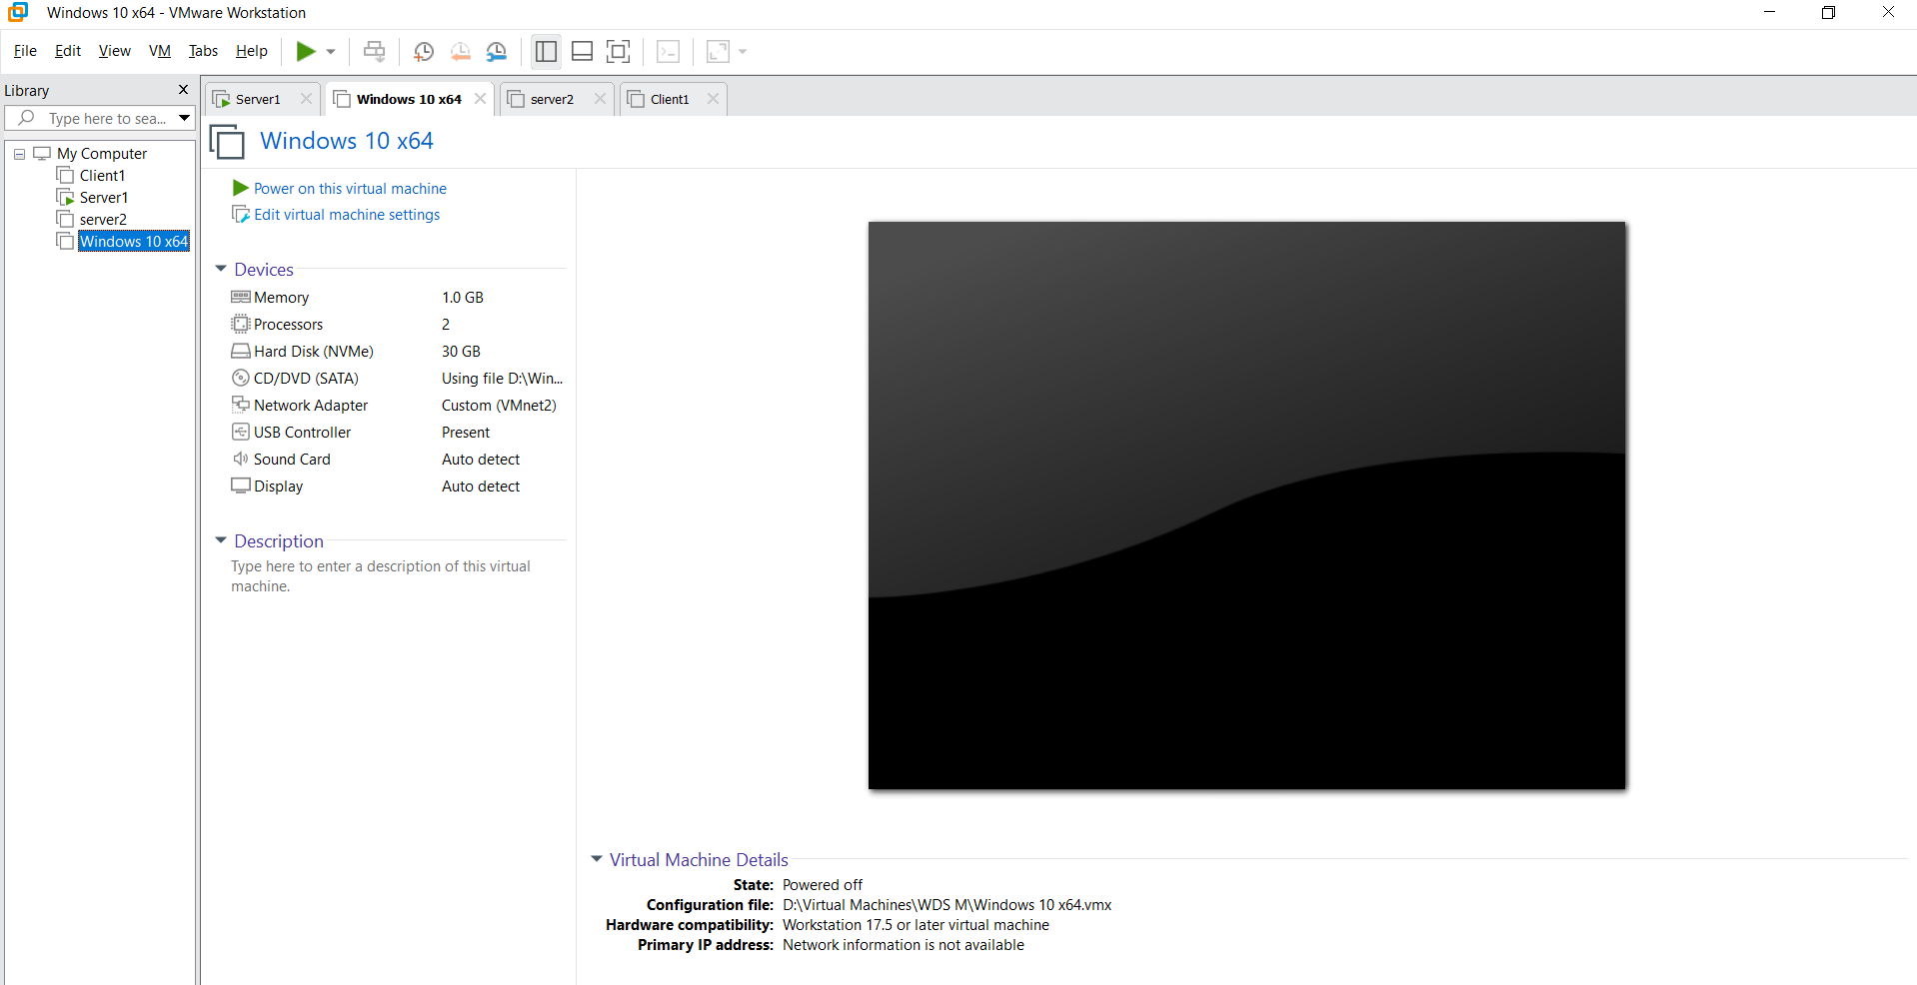

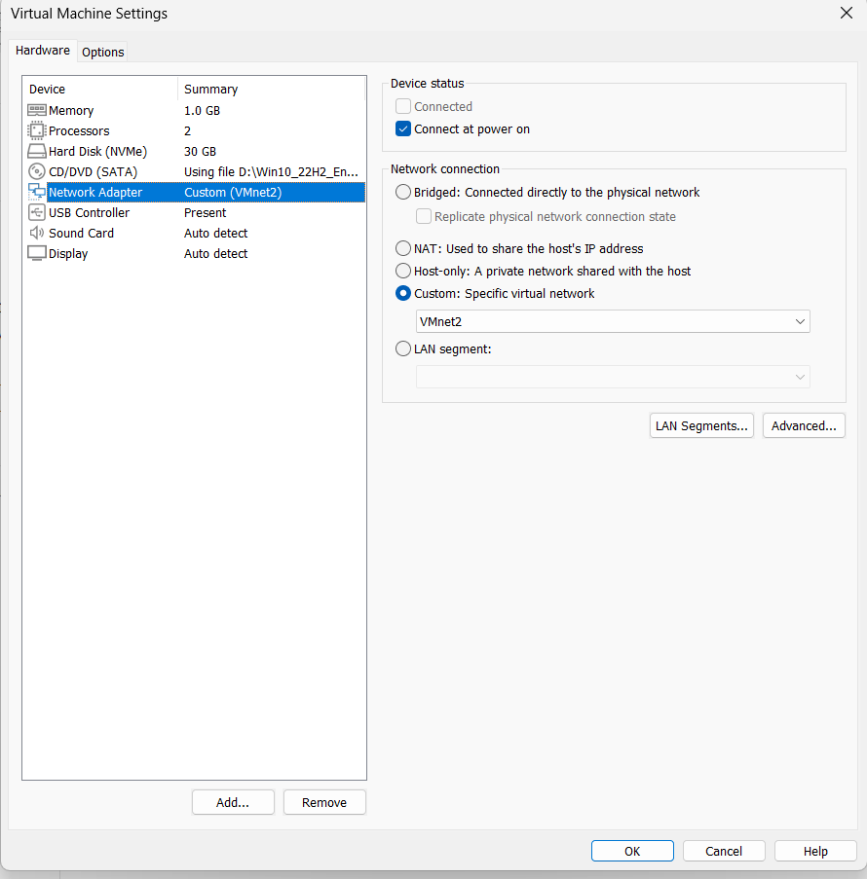
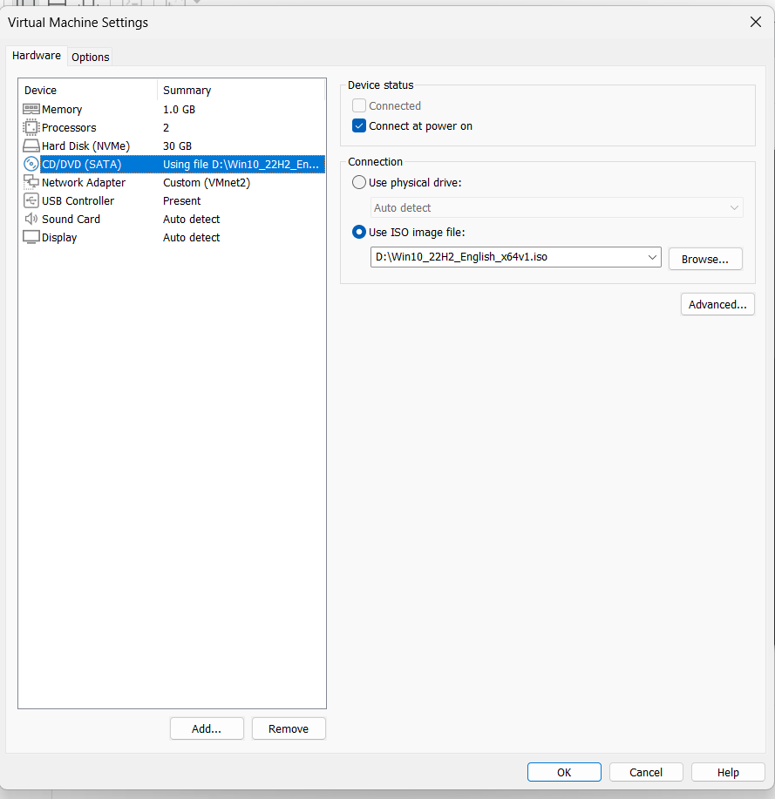
10. Power on Window 10 x64 press ctrl+alt+Enter see the server1 ip(192.168.10.1) wait give username: Microsoft\administrator and Password : Password@123 next last username: Admin and Password: Password@123 next

